Task 2:

Design a solution for a system to build IoT gateway which can collect various type of analog and digital sensor data as well as UART based sensor data, IoT gateway should be able to communicate with cloud platform over Ethernet or Wi-Fi interface, IoT gateway should be running Linux distributed system. IoT gateway should support OTA, self-memory management. IoT gateway should send health statistical data to the cloud periodically.

[Deliverables]: - Overall design document which should include, block diagram, hardware and software specifications, project plan and timeline diagram - Component selection matrix

Table of Contents

Block Diagram 2

Hardware Specification: 3

Raspberry pi 3: 3

Analogue Interface: 5

MUX: 5

UART Interface: 5

Cloud/OTA: 5

Self-Memory management/OTA: 5

Software Specification: 6

Project Plan 7

Timeline 8

# Block Diagram

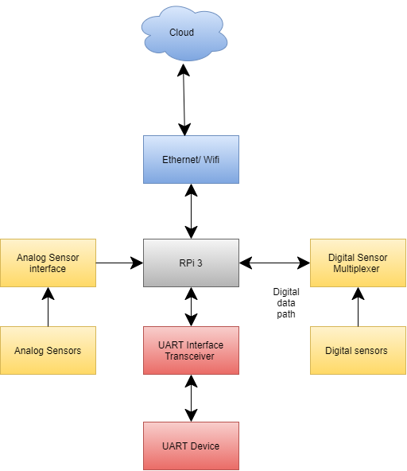

Figure 1: Block Diagram

# Hardware Specification:

## Raspberry pi 3:

Which support wifi and Ethernet both on chip, where we can enable OTA with tools like upswift. Main advantage of using raspberry pi for built in libraries so we can directly implement application for prototype. There are many GPIO available still sensors is more we can use MUX. It Is also loaded with UART port.

|  |  |
| --- | --- |
| Microprocessor | Broadcom BCM2837 64bit Quad Core Processor |
| Processor Operating Voltage | 3.3V |
| Raw Voltage input | 5V, 2A power source |
| Maximum current through each I/O pin | 16mA |
| Maximum total current drawn from all I/O pins | 54mA |
| Flash Memory (Operating System) | 16Gbytes SSD memory card |
| Internal RAM | 1Gbytes DDR2 |
| Clock Frequency | 1.2GHz |
| GPU | Dual Core Video Core IV® Multimedia Co-Processor. Provides Open GLES 2.0, hardware-accelerated Open VG, and 1080p30 H.264 high- profile decode.  Capable of 1Gpixel/s, 1.5Gtexel/s or 24GFLOPs with texture filtering and DMA infrastructure. |
| Ethernet | 10/100 Ethernet |
| Wireless Connectivity | BCM43143 (802.11 b/g/n Wireless LAN and Bluetooth 4.1) |
| Operating Temperature | -40ºC to +85ºC |

## Analogue Interface:

There are different sensors which have different analogue values to match with our controller voltage level we can design some circuit like voltage divider. So we can get desired input according controller.

## MUX:

If there are many sensors so we can use multiplexer and we can get 2^n sensors data with using selection line. We can use different MUX according to application.

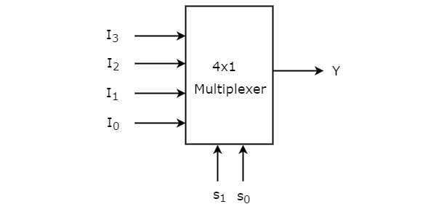

Figure 2:MUX Working Principle

## UART Interface:

UART interface is built in available for hardware still we need to map to another port to debug device we can achieve with some transceiver.

## Cloud/OTA:

Cloud is totally depending on how many device and how much data we need to capture, but here for OTA support will be supported. So we can choose cloud accordingly. Mediatek sandbox can be used for testing purpose.

## Self-Memory management/OTA:

There are many option available because it is linux environment, For proto type we can use upswift then after product we can use our own algorithm.

# Software Specification:

Application: Python

Drivers: Embedded C

GUI: Python tkinter

Health statistical data: SNMP protocol

IOT: MQTT protocol

OS: Raspberry Pi OS

# Project Plan

Engineer required:2 (Firmware and Networking)

|  |  |
| --- | --- |
| Firmware | Networking |
| Driver Development(ADC,UART) | Diver development(Ethernet, WIfi) |
| OS Scheduling | Cloud API management |
| GPIO management | OTA |
| Self-Memory management | MQTT development |
| Sensor/UART data management | Protocol frame management according data |

# Timeline

Total time: 2 Months

Driver development: 2 weeks

OS scheduling :2 days

Firmware and application: 1 week

MQTT: 3 days

UART: 2 days

OTA/Self Memory management: 1 week

SNMP: 3 days

Integration: 4 days

Testing: 1 week

Buffer time: 1 week